Cognate Object

✅ What Is a Cognate Object?
# Source: Chatbot (GPT-4-turbo) at [8/4/2025]
A Cognate Object is a noun that is etymologically related to the verb in the sentence.
It usually repeats or reinforces the meaning of the verb and often appears with an adjective or modifier to add meaning.

🔸 Key Features:
# Source: Chatbot (GPT-4-turbo) at [8/4/2025]
- The object shares the same linguistic root as the verb.
- Often used for emphasis, style, or poetic expression.
- Usually formed as [verb] + [noun of same root].
- Common in formal, literary, or older English.

🔸 Examples of Cognate Objects:
# Source: Chatbot (GPT-4-turbo) at [8/4/2025]
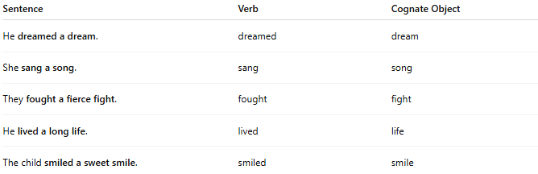
Sentence | Verb | Cognate Object
He dreamed a dream. | dreamed | dream
She sang a song. | sang | song
They fought a fierce fight. | fought | fight
He lived a long life. | lived | life
The child smiled a sweet smile. | smiled | smile

🔸 How to Identify a Cognate Object:
# Source: Chatbot (GPT-4-turbo) at [8/4/2025]
Ask:
- Does the object come from the same root as the verb?
- Is the object used more for stylistic emphasis than for new information?
✅ Example:
- "He danced a dance." → Verb = danced, Object = dance → same root → Cognate Object

🔸 Cognate Object vs Regular Direct Object:
# Source: Chatbot (GPT-4-turbo) at [8/4/2025]
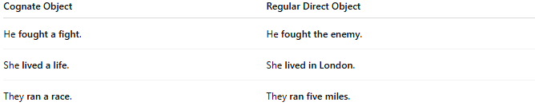
Cognate Object | Regular Direct Object
He fought a fight. | He fought the enemy.
She lived a life. | She lived in London.
They ran a race. | They ran five miles.

